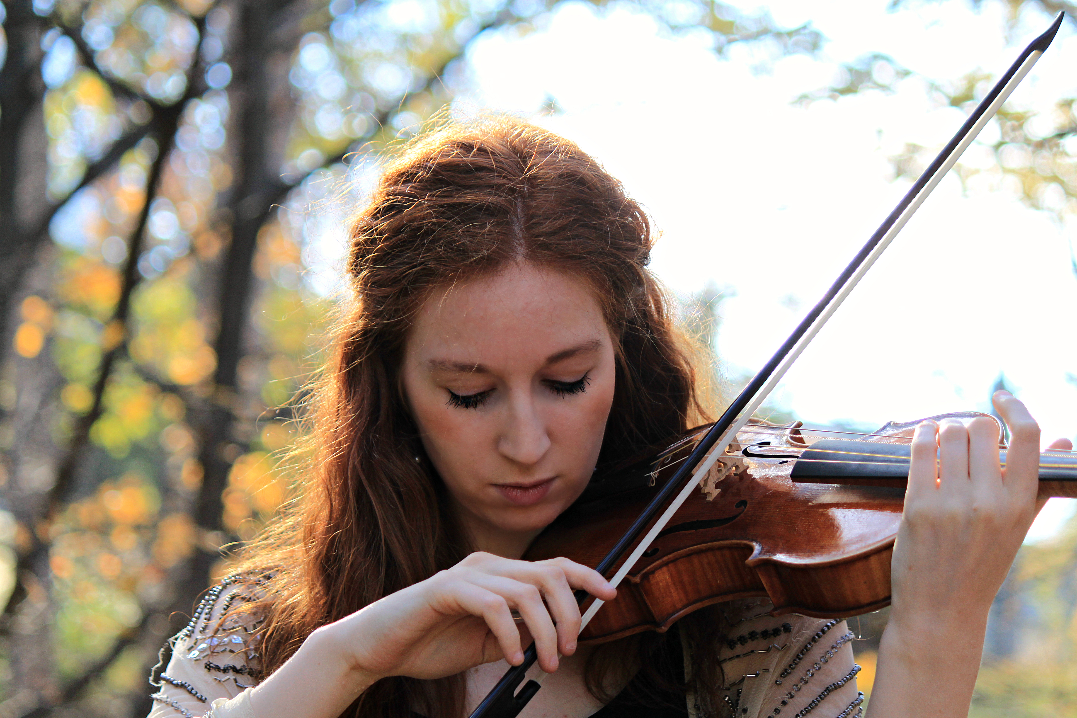
Augusta McKay Lodge is an award-winning historically informed violinist, enjoying a blossoming career as leader and soloist at a young age. Already an experienced leader in the field, McKay Lodge performs regularly as concertmaster with Les Arts Florissants and Les Musiciens de Saint-Julien, and recently with Opera Fuoco at the Theatre des Champs-Elysees. She has also guest directed the Philharmonia Baroque Orchestra Chamber Players as a substitute for Richard Egarr. In the past, she has held concertmaster of Bach Akademie Charlotte, The American Classical Orchestra, and Teatro Nuovo. As a soloist, McKay Lodge has enjoyed multiple concerto appearances with the Indianapolis Baroque Orchestra, Juilliard415, and Voices of Music. She has appeared in Carnegie Hall, Lincoln Center’s Alice Tully Hall, the Concertgebouw’s Kleine Zaal, the Metropolitan Museum, the Kosciuszko Foundation, and William Christie’s festival Dans les Jardins de William Christie. A regular violinist with Voices of Music, she solos in numerous 4k high-definition videos on their successful YouTube channel. McKay Lodge’s discography includes award-winning, globally recognized solo albums Beyond Bach and Vivaldi and Corelli’s Band (Naxos), and an equally acclaimed chamber music disc with her sister Georgina McKay Lodge, J.G. Graun: Chamber Music from the Court of Frederick the Great (Brilliant Classics). An avid chamber musician, McKay Lodge is a founding member of ensembles Voyage Sonique (New York) and Spielerei Piano Trio (Amsterdam). She performs regularly with the Ensemble Jupiter, including their recent rave debut at Carnegie Hall, and Le Consort in France. McKay Lodge is an English Concert American Fellow, a Juilliard-Mercury Fellow, and a Kovner Fellow, and holds degrees from Oberlin Conservatory of Music, Indiana University Jacobs School, and from The Juilliard School, completing her education at just 25 years old. McKay Lodge performs on a historical Jean-Baptiste Vuillaume (1867) and a baroque-copy Jason Viseltear (2014) violins, depending on the repertoire. She is based in Paris, France. Further information can be found at www.augustamckaylodge.com.

